


BACHELOR OF TECHNOLOGY COMPUTER SCIENCE AND ENGINEERING

WEB PROGRAMMING WITH PYTHON AND JAVASCRIPT LAB

SEC035 LAB PRACTICALS
SUBMITTED BY : NAME : PREM KUMAR BTECH CSE CORE
SEMESTER : IV SECTION : B
ROLL : 2401010243

SUBMITTED TO :
MS. MANSI KAJAL MAM

INDEX

S. No. | AIM
1.  2.  3.  4.  5.  6.  7. | Personal Portfolio Web Application  Company Landing Page Website  Interactive Quiz Project  Dynamic To-Do List App

EXPERIMENT - I

Aim :
Creating a Personal Portfolio Web Application with HTML, CSS Styling and JavaScript

Tasks
- Create the basic project setup with linked HTML, CSS, and JavaScript files.
- Design a structured portfolio layout using semantic HTML elements.
- Apply CSS styling for proper layout, colors, fonts, and spacing.
- Display skills and projects in an organized manner.
- Add basic JavaScript interactivity such as alerts or section toggling.

Technology Stack Used
- HTML5 – For creating the structure of the portfolio website
- CSS3 – For styling, layout, and visual presentation
- JavaScript – For adding basic interactivity and DOM manipulation
- Web Browser – For testing and running the website locally

- CODES :
- HTML CODE :

<!DOCTYPE html>
<html lang="en">
<head>
<!--
Project: Personal Portfolio Website
Developer: Prem Kumar
-->
<meta charset="UTF-8">
<meta name="viewport" content="width=device-width, initial-scale=1.0">
<title>Personal Portfolio - Prem Kumar</title>
<link rel="stylesheet" href="style.css">
</head>
<body>

<!-- Header Section -->
<header>
<h1>Prem Kumar</h1>
<p class="tagline">B.Tech CSE Student | Aspiring Web Developer</p>
</header>

<!-- Navigation Bar -->
<nav>
<a href="#welcome">Home</a>
<a href="#about">About</a>
<a href="#skills">Skills</a>
<a href="#projects">Projects</a>
<a href="#contact">Contact</a>
</nav>

<!-- Welcome Section -->
<section id="welcome" class="welcome-section">
<h2>Welcome to My Portfolio</h2>
<p>
Welcome to my personal portfolio website. This platform highlights my
technical skills, academic background, and sample projects developed
using web technologies.
</p>
<button id="welcomeBtn" class="btn-primary">Thank You for Visiting!</button>
</section>

<!-- About Me Section -->
<section id="about" class="about-section">
<h2>About Me</h2>
<p>
I am a Computer Science Engineering student with a strong interest in
front-end web development. I enjoy transforming ideas into clean,
responsive, and user-friendly web interfaces.
</p>
<p>
Currently, I am improving my skills in HTML, CSS, and JavaScript while
working on academic and personal projects.
</p>
</section>

<!-- Skills Section -->
<section id="skills" class="skills-section">
<h2>Technical Skills</h2>
<div class="skills-container">
<div class="skill-card">
<h3>HTML5</h3>
<p>Semantic structure and accessibility</p>
</div>
<div class="skill-card">
<h3>CSS3</h3>
<p>Layout, styling, flexbox, and responsive design</p>
</div>
<div class="skill-card">
<h3>JavaScript</h3>
<p>Basic logic and DOM manipulation</p>
</div>
<div class="skill-card">
<h3>Java</h3>
<p>Object-oriented programming fundamentals</p>
</div>
<div class="skill-card">
<h3>Data Structures</h3>
<p>Arrays, strings, recursion, problem-solving</p>
</div>
<div class="skill-card">
<h3>C / C++</h3>
<p>Programming fundamentals</p>
</div>
</div>
</section>

<!-- Projects Section -->
<section id="projects" class="projects-section">
<h2>Projects</h2>
<div class="projects-container">
<div class="project-card">
<h3>Personal Portfolio Website</h3>
<p>
A responsive and professional portfolio website created using
semantic HTML and modern CSS design principles. Features interactive
JavaScript elements for enhanced user experience.
</p>
<div class="project-tags">
<span class="tag">HTML</span>
<span class="tag">CSS</span>
<span class="tag">JavaScript</span>
</div>
</div>

<div class="project-card">
<h3>Temperature Conversion Tool</h3>
<p>
A simple project concept designed to convert temperature values
between Celsius and Fahrenheit using basic logic and DOM manipulation.
</p>
<div class="project-tags">
<span class="tag">JavaScript</span>
<span class="tag">HTML</span>
</div>
</div>

<div class="project-card">
<h3>Student Management System</h3>
<p>
A console-based application to manage student records including
adding, updating, and deleting student information using Java.
</p>
<div class="project-tags">
<span class="tag">Java</span>
<span class="tag">OOP</span>
</div>
</div>
</div>
<button id="toggleProjects" class="btn-secondary">Hide Projects</button>
</section>

<!-- Contact Section -->
<section id="contact" class="contact-section">
<h2>Contact Me</h2>
<div class="contact-info">
<p><strong>Email:</strong> pkyt090@gmail.com</p>
<p><strong>Phone:</strong> +91-7701898396</p>
<p><strong>Location:</strong> Delhi, India</p>
</div>

<!-- Contact Form -->
<div class="contact-form-container">
<h3>Send Me a Message</h3>
<form id="contactForm">
<div class="form-group">
<label for="name">Name:</label>
<input type="text" id="name" name="name" required>
</div>

<div class="form-group">
<label for="email">Email:</label>
<input type="email" id="email" name="email" required>
</div>

<div class="form-group">
<label for="message">Message:</label>
<textarea id="message" name="message" rows="5" required></textarea>
</div>

<button type="submit" class="btn-primary">Send Message</button>
</form>
<div id="formMessage" class="form-message"></div>
</div>

<button id="scrollToTop" class="btn-secondary scroll-btn">Scroll to Top</button>
</section>
<!-- Footer -->
<footer>
<p> Prem Kumar</p>
</footer>

<!-- Link to JavaScript File -->
<script src="script.js"></script>

</body>
</html>

- CSS CODE :

/* Global Reset and Base Styles */
* {
margin: 0;
padding: 0;
box-sizing: border-box;
}

body {
font-family: 'Segoe UI', Tahoma, Geneva, Verdana, sans-serif;
line-height: 1.6;
color: #333;
background-color: #f4f4f4;
}

/* Header Styles */
header {
background: linear-gradient(135deg, #667eea 0%, #764ba2 100%);
color: white;
text-align: center;
padding: 3rem 2rem;
box-shadow: 0 4px 6px rgba(0, 0, 0, 0.1);
}

header h1 {
font-size: 2.5rem;
margin-bottom: 0.5rem;
text-shadow: 2px 2px 4px rgba(0, 0, 0, 0.2);
}

.tagline {
font-size: 1.2rem;
font-weight: 300;
opacity: 0.95;
}

/* Navigation Styles */
nav {
background-color: #2c3e50;
padding: 1rem;
text-align: center;
box-shadow: 0 2px 4px rgba(0, 0, 0, 0.1);
position: sticky;
top: 0;
z-index: 100;
}

nav a {
color: white;
text-decoration: none;
padding: 0.75rem 1.5rem;
margin: 0 0.5rem;
border-radius: 5px;
transition: background-color 0.3s ease, transform 0.2s ease;
display: inline-block;
}

nav a:hover {
background-color: #34495e;
transform: translateY(-2px);
}

/* Section Styles */
section {
max-width: 1200px;
margin: 2rem auto;
padding: 2rem;
background-color: white;
border-radius: 10px;
box-shadow: 0 2px 10px rgba(0, 0, 0, 0.1);
}

section h2 {
color: #667eea;
font-size: 2rem;
margin-bottom: 1.5rem;
border-bottom: 3px solid #667eea;
padding-bottom: 0.5rem;
}

/* Welcome Section */
.welcome-section {
text-align: center;
background: linear-gradient(135deg, #f093fb 0%, #f5576c 100%);
color: white;
}

.welcome-section h2 {
color: white;
border-bottom: 3px solid white;
}

.welcome-section p {
font-size: 1.1rem;
margin-bottom: 1.5rem;
}

/* About Section */
.about-section p {
margin-bottom: 1rem;
font-size: 1.05rem;
text-align: justify;
}

/* Skills Section */
.skills-section {
background-color: #f8f9fa;
}

.skills-container {
display: grid;
grid-template-columns: repeat(auto-fit, minmax(250px, 1fr));
gap: 1.5rem;
margin-top: 1.5rem;
}

.skill-card {
background-color: white;
padding: 1.5rem;
border-radius: 8px;
border-left: 4px solid #667eea;
box-shadow: 0 2px 8px rgba(0, 0, 0, 0.1);
transition: transform 0.3s ease, box-shadow 0.3s ease;
}

.skill-card:hover {
transform: translateY(-5px);
box-shadow: 0 4px 12px rgba(102, 126, 234, 0.3);
}

.skill-card h3 {
color: #667eea;
margin-bottom: 0.5rem;
font-size: 1.3rem;
}

.skill-card p {
color: #666;
font-size: 0.95rem;
}

/* Projects Section */
.projects-container {
display: grid;
grid-template-columns: repeat(auto-fit, minmax(300px, 1fr));
gap: 2rem;
margin-top: 1.5rem;
}

.project-card {
background-color: white;
padding: 1.5rem;
border-radius: 8px;
border: 1px solid #e0e0e0;
box-shadow: 0 3px 10px rgba(0, 0, 0, 0.1);
transition: transform 0.3s ease, box-shadow 0.3s ease;
}

.project-card:hover {
transform: translateY(-8px);
box-shadow: 0 6px 20px rgba(0, 0, 0, 0.15);
}

.project-card h3 {
color: #2c3e50;
margin-bottom: 1rem;
font-size: 1.4rem;
}

.project-card p {
color: #555;
margin-bottom: 1rem;
line-height: 1.8;
}

.project-tags {
display: flex;
flex-wrap: wrap;
gap: 0.5rem;
}

.tag {
background-color: #667eea;
color: white;
padding: 0.3rem 0.8rem;
border-radius: 20px;
font-size: 0.85rem;
font-weight: 500;
}

/* Contact Section */
.contact-section {
background-color: #f8f9fa;
}

.contact-info {
margin-bottom: 2rem;
padding: 1.5rem;
background-color: white;
border-radius: 8px;
border-left: 4px solid #667eea;
}

.contact-info p {
margin-bottom: 0.5rem;
font-size: 1.05rem;
}

/* Contact Form Styles */
.contact-form-container {
background-color: white;
padding: 2rem;
border-radius: 8px;
box-shadow: 0 2px 8px rgba(0, 0, 0, 0.1);
margin-bottom: 2rem;
}

.contact-form-container h3 {
color: #2c3e50;
margin-bottom: 1.5rem;
}

.form-group {
margin-bottom: 1.5rem;
}

.form-group label {
display: block;
margin-bottom: 0.5rem;
font-weight: 600;
color: #333;
}

.form-group input,
.form-group textarea {
width: 100%;
padding: 0.75rem;
border: 2px solid #e0e0e0;
border-radius: 5px;
font-size: 1rem;
font-family: inherit;
transition: border-color 0.3s ease;
}

.form-group input:focus,
.form-group textarea:focus {
outline: none;
border-color: #667eea;
}

.form-message {
margin-top: 1rem;
padding: 1rem;
border-radius: 5px;
text-align: center;
font-weight: 600;
display: none;
}

.form-message.success {
background-color: #d4edda;
color: #155724;
border: 1px solid #c3e6cb;
display: block;
}

.form-message.error {
background-color: #f8d7da;
color: #721c24;
border: 1px solid #f5c6cb;
display: block;
}

/* Button Styles */
.btn-primary,
.btn-secondary {
padding: 0.75rem 2rem;
border: none;
border-radius: 5px;
font-size: 1rem;
cursor: pointer;
transition: all 0.3s ease;
font-weight: 600;
margin: 0.5rem;
}

.btn-primary {
background: linear-gradient(135deg, #667eea 0%, #764ba2 100%);
color: white;
}

.btn-primary:hover {
transform: translateY(-2px);
box-shadow: 0 4px 12px rgba(102, 126, 234, 0.4);
}

.btn-secondary {
background-color: #2c3e50;
color: white;
}

.btn-secondary:hover {
background-color: #34495e;
transform: translateY(-2px);
}

.scroll-btn {
display: block;
margin: 2rem auto 0;
}

/* Footer Styles */
footer {
background-color: #2c3e50;
color: white;
text-align: center;
padding: 2rem;
margin-top: 2rem;
}

footer p {
margin: 0.5rem 0;
}

/* Responsive Design */
@media (max-width: 768px) {
header h1 {
font-size: 2rem;
}

nav a {
display: block;
margin: 0.5rem 0;
}

section {
margin: 1rem;
padding: 1.5rem;
}

section h2 {
font-size: 1.5rem;
}

.skills-container,
.projects-container {
grid-template-columns: 1fr;
}
}

/* Hidden class for JavaScript toggle */
.hidden {
display: none !important;
}

- JAVASCRIPT CODE :

function welcomeAlert() {
alert("Thank you for visiting my portfolio!");
}

function submitForm(event) {
event.preventDefault();
document.getElementById("msg").innerText = "Message submitted successfully!";
}

- OUTPUT:

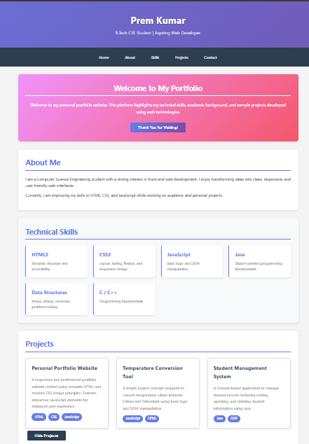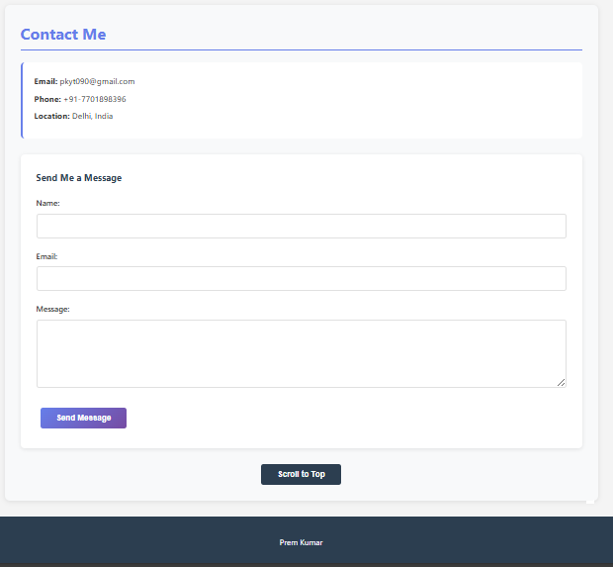

EXPERIMENT - II

Aim :
To design a simple company landing page using HTML and CSS with proper structure and styling.

Tasks :
- Project Setup & Introduction – Create project folder with linked HTML and CSS files and add company introduction.
- HTML Structure – Build landing page sections using semantic HTML elements.

- Styling with CSS – Apply layout, colors, spacing, and professional design.

- Services Section Design – Display company services clearly using cards or grid layout.

- Testimonials Section – Add and format customer testimonials for better presentation.

- Contact Section (Bonus) – Create contact details and a simple contact form UI.

Tech Stack Used :
  - HTML , CSS and JavaScript

- CODES :
- HTML CODE :
<!DOCTYPE html>
<html lang="en">
<head>
<meta charset="UTF-8">
<title>RouteMint | Smart Travel Planner</title>
<link rel="stylesheet" href="style.css">
</head>
<body>

<header class="hero">
<div class="hero-media">
<video class="hero-video" autoplay muted loop playsinline>
<source src="media/hero-travel.mp4.mp4" type="video/mp4">
</video>
<div class="hero-overlay"></div>
</div>

<div class="hero-content">
<h1>RouteMint</h1>
<p class="tagline">Smart travel planning made simple</p>
<p class="subtext">
Build routes, track costs, and discover hidden gems in one clean dashboard.
</p>
<div class="hero-actions">
<a class="btn primary" href="#contact">Get Started</a>
<a class="btn ghost" href="#features">View Features</a>
</div>
</div>
</header>

<section id="about">
<h2>About RouteMint</h2>
<p>RouteMint helps you plan efficient, budget-friendly, and stress-free trips.</p>

<div class="about-grid">
<div class="about-card">
<h3>Plan Smarter</h3>
<p>Optimized routes and day-wise planning.</p>
</div>
<div class="about-card">
<h3>Spend Better</h3>
<p>Automatic budget tracking and alerts.</p>
</div>
<div class="about-card">
<h3>Travel Confidently</h3>
<p>Destination tips and seasonal insights.</p>
</div>
</div>
</section>

<section id="features">
<h2>Key Features</h2>
<div class="features">
<div class="feature-card">
<h3>Smart Route Builder</h3>
<p>Auto-generated optimized routes.</p>
</div>
<div class="feature-card">
<h3>Budget Tracker</h3>
<p>Real-time expense monitoring.</p>
</div>
<div class="feature-card">
<h3>Local Recommendations</h3>
<p>Food, places & hidden gems.</p>
</div>
<div class="feature-card">
<h3>Offline Access</h3>
<p>View itinerary without internet.</p>
</div>
</div>
</section>

<section id="services">
<h2>Our Services</h2>
<div class="services">
<div class="service-card">
<h3>Itinerary Planning</h3>
<p>Time & distance based planning.</p>
</div>
<div class="service-card">
<h3>Destination Insights</h3>
<p>Travel tips and attractions.</p>
</div>
<div class="service-card">
<h3>Budget Management</h3>
<p>Expense estimation and tracking.</p>
</div>
<div class="service-card">
<h3>Team Travel</h3>
<p>Share plans and split costs.</p>
</div>
</div>
</section>

<section id="stats">
<h2>Travel Impact</h2>
<div class="stats">
<div class="stat-card">
<h3>120K+</h3>
<p>Trips Planned</p>
</div>
<div class="stat-card">
<h3>4.8★</h3>
<p>User Rating</p>
</div>
<div class="stat-card">
<h3>65%</h3>
<p>Cost Savings</p>
</div>
<div class="stat-card">
<h3>50+</h3>
<p>Cities Covered</p>
</div>
</div>
</section>

<section id="testimonials">
<h2>User Feedback</h2>

<div class="testimonial">
<p>“RouteMint made trip planning effortless.”</p>
<span>- Vansh Sharma</span>
</div>
<div class="testimonial">
<p>“Simple, clean, and very useful.”</p>
<span>- Prem Kumar</span>
</div>
<div class="testimonial">
<p>“Perfect for group trips.”</p>
<span>- Utsav Ratan</span>
</div>
</section>

<section id="faq">
<h2>FAQs</h2>
<div class="faq">
<div class="faq-item">
<h3>Is it free?</h3>
<p>Yes, basic features are free.</p>
</div>
<div class="faq-item">
<h3>Group trips supported?</h3>
<p>Yes, collaborate easily.</p>
</div>
<div class="faq-item">
<h3>Offline access?</h3>
<p>Yes, itinerary works offline.</p>
</div>
</div>
</section>

<section id="contact">
<h2>Contact</h2>
<div class="contact-info">
<p>Email: support@routemint.com</p>
<p>Phone: +91 98765 43210</p>
<p>Location: Gurugram, Haryana</p>
</div>

<form>
<input type="text" placeholder="Your Name" required>
<input type="email" placeholder="Your Email" required>
<textarea placeholder="Your Message"></textarea>
<button type="submit">Send Message</button>
</form>
</section>

<section id="cta">
<h2>Ready to plan your next trip?</h2>
<p>Start building smarter itineraries today.</p>
<a class="btn primary" href="#contact">Start Planning</a>
</section>

<footer>
<p>© 2026 RouteMint | Smart Travel Planner</p>
</footer>

</body>
</html>

- CSS CODE :
*,
*::before,
*::after {
box-sizing: border-box;
}

html {
scroll-behavior: smooth;
}

body {
margin: 0;
font-family: "Inter", "Segoe UI", Arial, sans-serif;
background: linear-gradient(135deg, #f5f7fa 0%, #c3cfe2 100%);
color: #2c3e50;
line-height: 1.6;
}

/* Hero */
.hero {
color: white;
text-align: center;
padding: 80px 20px;
position: relative;
overflow: hidden;
min-height: 70vh;
display: flex;
align-items: center;
justify-content: center;
}

.hero-media {
position: absolute;
inset: 0;
z-index: 0;
}

.hero-video {
width: 100%;
height: 100%;
object-fit: cover;
pointer-events: none;
}

.hero-overlay {
position: absolute;
inset: 0;
background: linear-gradient(
180deg,
rgba(15, 27, 45, 0.65),
rgba(15, 27, 45, 0.85)
);
}

.hero-content {
position: relative;
z-index: 1;
max-width: 900px;
}

.hero h1 {
font-size: 54px;
margin-bottom: 5px;
font-weight: 700;
}

.tagline {
font-size: 24px;
font-weight: 600;
margin-bottom: 15px;
}

.subtext {
font-size: 16px;
opacity: 0.95;
max-width: 600px;
margin: 0 auto;
}

.hero-actions {
margin-top: 24px;
display: flex;
gap: 16px;
justify-content: center;
flex-wrap: wrap;
}

.btn {
display: inline-block;
padding: 12px 22px;
border-radius: 8px;
font-weight: 600;
text-decoration: none;
transition: all 0.3s ease;
}

.btn.primary {
background: white;
color: #667eea;
box-shadow: 0 10px 20px rgba(0, 0, 0, 0.15);
}

.btn.primary:hover {
transform: translateY(-3px);
box-shadow: 0 14px 28px rgba(0, 0, 0, 0.2);
}

.btn.ghost {
border: 2px solid rgba(255, 255, 255, 0.6);
color: white;
}

.btn.ghost:hover {
background: rgba(255, 255, 255, 0.1);
}

/* Sections */
section {
background-color: white;
width: 85%;
margin: 50px auto;
padding: 60px 45px;
border-radius: 15px;
box-shadow: 0 10px 40px rgba(0, 0, 0, 0.08);
}

h2 {
text-align: center;
margin-bottom: 40px;
color: #667eea;
font-size: 32px;
font-weight: 700;
}

/* About */
.about-grid {
display: grid;
grid-template-columns: repeat(auto-fit, minmax(220px, 1fr));
gap: 24px;
}

.about-card {
padding: 22px;
border-radius: 12px;
background: #f7f9ff;
border: 1px solid #e6ecff;
transition: 0.3s;
}

.about-card:hover {
transform: translateY(-6px);
}

/* Features */
.features {
display: grid;
grid-template-columns: repeat(auto-fit, minmax(220px, 1fr));
gap: 24px;
}

.feature-card {
padding: 22px;
border-radius: 12px;
background: white;
border: 1px solid #eef1ff;
box-shadow: 0 8px 18px rgba(102, 126, 234, 0.08);
transition: 0.3s;
}

.feature-card:hover {
transform: translateY(-6px);
}

/* Services */
.services {
display: grid;
grid-template-columns: repeat(auto-fit, minmax(280px, 1fr));
gap: 35px;
}

.service-card {
background: linear-gradient(135deg, #f5f7fa, #c3cfe2);
padding: 35px;
border-radius: 12px;
text-align: center;
transition: 0.3s;
}

.service-card:hover {
background: linear-gradient(135deg, #667eea, #764ba2);
color: white;
transform: translateY(-10px);
}

.service-card h3 {
color: #667eea;
}

.service-card:hover h3 {
color: white;
}

/* Stats */
.stats {
display: grid;
grid-template-columns: repeat(auto-fit, minmax(160px, 1fr));
gap: 20px;
text-align: center;
}

.stat-card {
background: white;
padding: 22px;
border-radius: 12px;
border: 1px solid #edf0ff;
}

.stat-card h3 {
color: #667eea;
font-size: 28px;
}

/* Testimonials */
#testimonials {
background: linear-gradient(135deg, #e0f7ff, #f0e6ff);
}

.testimonial {
background: white;
padding: 30px;
margin: 20px auto;
width: 75%;
border-left: 5px solid #667eea;
border-radius: 8px;
}

.testimonial span {
font-weight: 600;
color: #667eea;
}

/* FAQ */
.faq {
display: grid;
gap: 16px;
}

.faq-item {
background: #f8f9ff;
padding: 18px;
border-radius: 10px;
}

/* Contact */
.contact-info {
text-align: center;
margin-bottom: 40px;
}

form {
max-width: 500px;
margin: auto;
}

input,
textarea {
width: 100%;
padding: 14px;
margin-top: 15px;
border-radius: 8px;
border: 2px solid #e8eef7;
}

input:focus,
textarea:focus {
border-color: #667eea;
outline: none;
}

button {
width: 100%;
margin-top: 20px;
padding: 14px;
background: linear-gradient(135deg, #667eea, #764ba2);
color: white;
border: none;
border-radius: 8px;
cursor: pointer;
}

/* CTA */
#cta {
background: linear-gradient(135deg, #667eea, #764ba2);
text-align: center;
color: white;
}

/* Footer */
footer {
background: #2c3e50;
color: white;
text-align: center;
padding: 30px;
}

/* Responsive */
@media (max-width: 768px) {
.hero h1 {
font-size: 36px;
}

section {
width: 90%;
padding: 40px 25px;
}

.testimonial {
width: 90%;
}

.hero-actions {
flex-direction: column;
}
}

- OUTPUT:

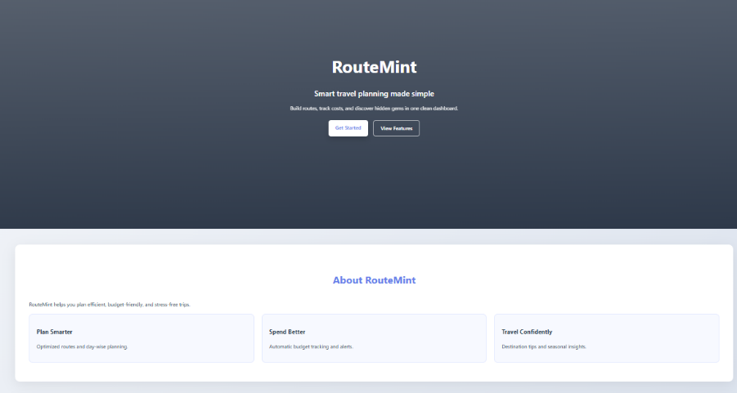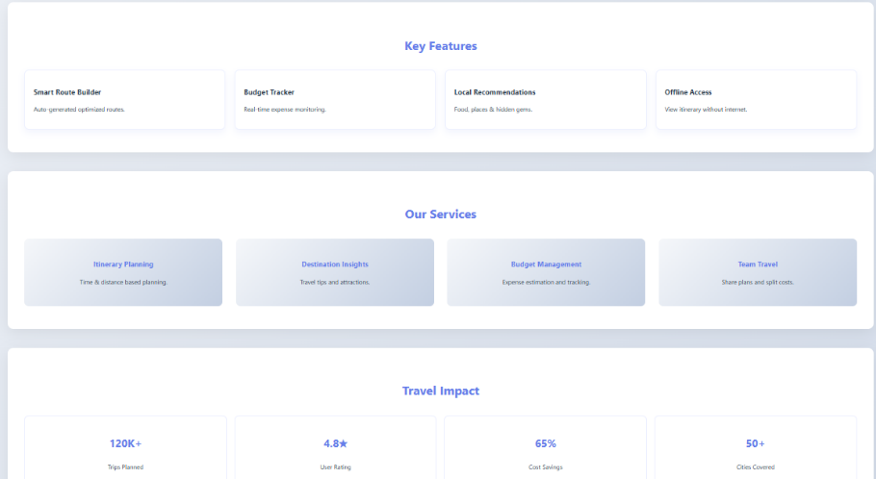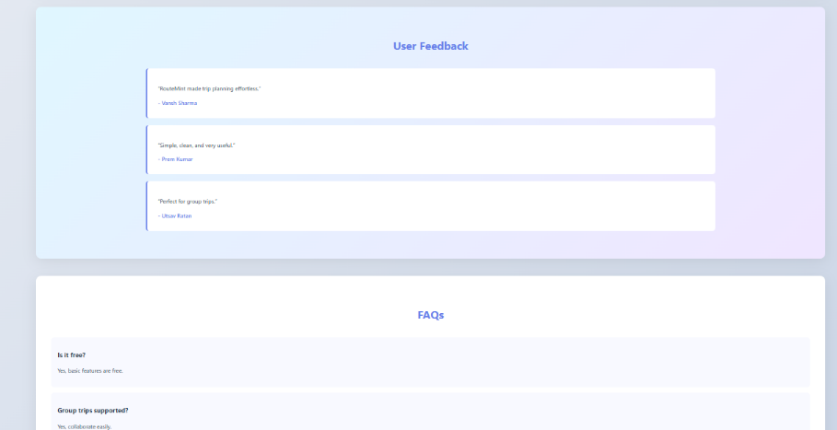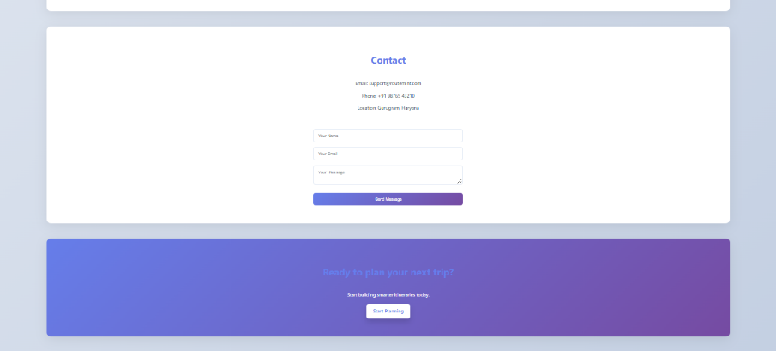

EXPERIMENT - III
- Aim :
To design and develop a basic interactive quiz application that evaluates user knowledge through multiple-choice questions with dynamic scoring and result display.
- Tasks :
- Project – Create and link HTML, CSS, and JavaScript files.
- HTML Structure – Design the basic quiz layout using semantic elements.
- Styling with CSS – Apply clean layout, spacing, and simple design.
- Questions Display – Show multiple-choice questions with selectable options.
- JavaScript Interactivity – Add logic for answer selection and score calculation.

- Result Display – Show final score with feedback message.
- Restart Feature (Bonus) – Allow users to reset and retake the quiz.

Tech Stack Used :
  - HTML , CSS and JavaScript

- CODES :
- HTML CODE :

<!DOCTYPE html>
<html lang="en">
<head>
<meta charset="UTF-8">
<title>Interactive Quiz</title>
<link rel="stylesheet" href="style.css">
</head>
<body>

<header>
<h1>Interactive Quiz</h1>
<p>Test your knowledge with this simple quiz. Select the correct answer and click Next.</p>
</header>

<main id="quiz-container">
<section id="question-box">
<h2 id="question">Question text</h2>
<div id="options"></div>
<button id="next-btn">Next</button>
</section>

<section id="result-box" class="hidden">
<h2 id="score"></h2>
<p id="message"></p>
<button id="restart-btn">Restart Quiz</button>
</section>
</main>

<script src="script.js"></script>
</body>
</html>

- CSS CODE:

body {
font-family: Arial, sans-serif;
background: #121212;
color: #ffffff;
margin: 0;
text-align: center;
}

header {
padding: 20px;
background: #1e1e1e;
border-bottom: 1px solid #333;
}

#quiz-container {
margin-top: 40px;
}

#question-box {
background: #1e1e1e;
padding: 25px;
width: 350px;
margin: auto;
border-radius: 10px;
box-shadow: 0 0 10px #000;
}

#options button {
display: block;
width: 100%;
margin: 10px 0;
padding: 10px;
border: none;
border-radius: 6px;
background: #2c2c2c;
color: white;
cursor: pointer;
}

#options button:hover {
background: #3d3d3d;
}

#next-btn, #restart-btn {
margin-top: 15px;
padding: 10px 20px;
border: none;
border-radius: 6px;
background: #4caf50;
color: white;
cursor: pointer;
}

.hidden {
display: none;
}

- JS CODE:

const quizData = [
{
question: "Which language adds interactivity to a website?",
options: ["Java", "C", "JavaScript", "SQL"],
answer: 2,
},
{
question: "Which language is used for styling web pages?",
options: ["HTML", "CSS", "Python", "Java"],
answer: 1,
},
{
question: "What does HTML stand for?",
options: [
"Hyper Text Markup Language",
"High Transfer Machine Language",
"Hyper Tool Multi Language",
"Home Text Machine Language",
],
answer: 0,
},
];

let currentQuestion = 0;
let score = 0;
let selected = null;

const questionEl = document.getElementById("question");
const optionsEl = document.getElementById("options");
const nextBtn = document.getElementById("next-btn");
const resultBox = document.getElementById("result-box");
const scoreEl = document.getElementById("score");
const messageEl = document.getElementById("message");
const restartBtn = document.getElementById("restart-btn");

function loadQuestion() {
const q = quizData[currentQuestion];
questionEl.textContent = q.question;
optionsEl.innerHTML = "";
selected = null;

q.options.forEach((opt, index) => {
const btn = document.createElement("button");
btn.textContent = opt;

btn.onclick = () => {
selected = index;

// remove previous selection highlight
document
.querySelectorAll("#options button")
.forEach((b) => (b.style.background = "#2c2c2c"));

// highlight selected
btn.style.background = "#4caf50";
};

optionsEl.appendChild(btn);
});
}

nextBtn.onclick = () => {
if (selected === null) return;

if (selected === quizData[currentQuestion].answer) {
score++;
}

currentQuestion++;

if (currentQuestion < quizData.length) {
loadQuestion();
} else {
showResult();
}
};

function showResult() {
document.getElementById("question-box").classList.add("hidden");
resultBox.classList.remove("hidden");

scoreEl.textContent = `Your Score: ${score}/${quizData.length}`;

if (score === quizData.length) messageEl.textContent = "Excellent!";
else if (score >= quizData.length / 2) messageEl.textContent = "Good Job!";
else messageEl.textContent = "Try Again!";
}

restartBtn.onclick = () => {
currentQuestion = 0;
score = 0;
resultBox.classList.add("hidden");
document.getElementById("question-box").classList.remove("hidden");
loadQuestion();
};

// start quiz
loadQuestion();

- OUTPUT:

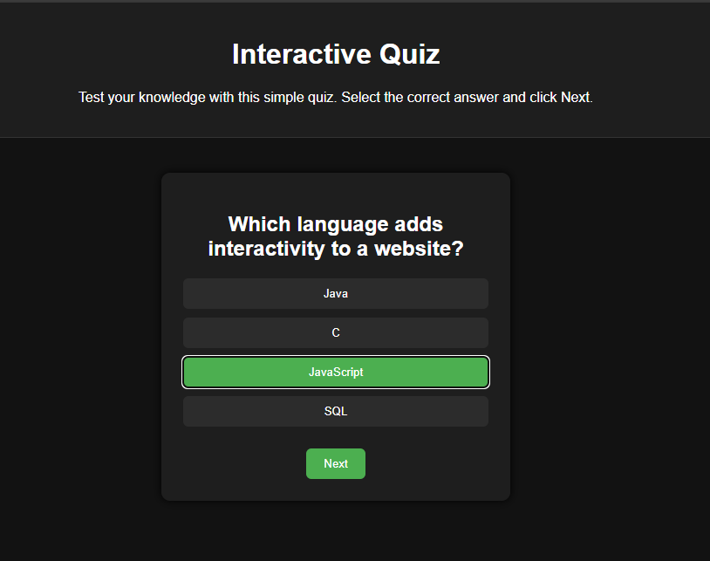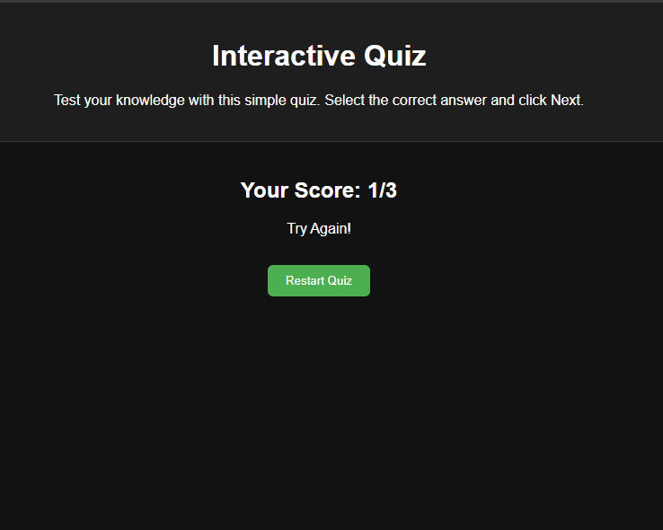

EXPERIMENT - IV
- Aim :
To develop a dynamic To-Do List web application using HTML, CSS, and JavaScript that allows users to add, edit, delete, and manage tasks efficiently.
- Tasks :
- Set up project files: index.html, style.css, script.js
- Create input field, add button, and task list (HTML)
- Style the interface for better UI (CSS)
- Add tasks dynamically and prevent empty inputs (JavaScript)
- Implement edit and delete features
- (Bonus) Add task completion with checkbox and visual effect

Tech Stack Used :
  - HTML , CSS and JavaScript

- CODES :
- HTML CODE :
<!DOCTYPE html>
<html lang="en">
<head>
<meta charset="UTF-8">
<meta name="viewport" content="width=device-width, initial-scale=1.0">
<title>Advanced To-Do List with Email Reminders</title>
<link rel="stylesheet" href="style.css">
</head>
<body>
<div class="background-gradient"></div>

<div class="container">
<!-- Header Section -->
<header class="header">
<div class="header-content">
<div class="logo">
<span class="logo-icon">✓</span>
</div>
<h1 class="header-title">TaskMaster</h1>
<p class="header-subtitle">Dynamic To-Do List </p>
</div>
</header>

<!-- Main Content Wrapper -->
<div class="content-wrapper">
<!-- Input Section -->
<section class="input-section">
<div class="section-header">
<h2>Create New Task</h2>
<span class="section-icon">📋</span>
</div>

<form class="input-form" id="taskForm">
<div class="form-group">
<label for="emailInput" class="form-label">Email Address</label>
<div class="input-wrapper">
<span class="input-icon">📧</span>
<input
type="email"
id="emailInput"
placeholder="your.email@example.com"
class="input-field"
required
>
</div>
</div>

<div class="form-row">
<div class="form-group">
<label for="reminderInput" class="form-label">Reminder Time</label>
<div class="input-wrapper">
<span class="input-icon">⏰</span>
<input
type="datetime-local"
id="reminderInput"
class="input-field"
title="Select when you want to receive the reminder"
required
>
</div>
</div>
</div>

<div class="form-group">
<label for="taskInput" class="form-label">Task Description</label>
<div class="input-wrapper">
<span class="input-icon">✏️</span>
<input
type="text"
id="taskInput"
placeholder="What needs to be done..."
class="input-field"
>
</div>
</div>

<button id="addBtn" class="btn btn-primary btn-add">
<span class="btn-icon">➕</span>
<span class="btn-text">Add Task</span>
</button>
</form>
</section>

<!-- Task List Section -->
<section class="tasks-section">
<div class="section-header">
<h2>Your Tasks</h2>
<span class="task-counter" id="taskCounter">0</span>
</div>
<div id="tasksList" class="tasks-list">
<p class="no-tasks">✨ No tasks yet. Create one to get started!</p>
</div>
</section>
</div>

<!-- Status Messages -->
<div id="statusMessage" class="status-message"></div>
</div>

<!-- Loading spinner -->
<div id="loadingSpinner" class="loading-spinner">
<div class="spinner"></div>
<p>Loading...</p>
</div>

<script src="script.js"></script>
</body>
</html>
- CSS CODE :
* {
margin: 0;
padding: 0;
box-sizing: border-box;
}

:root {
/* Dark Theme Colors */
--bg-primary: #0f0f1e;
--bg-secondary: #1a1a2e;
--bg-tertiary: #16213e;
--bg-card: #1f1f3d;

/* Accent Colors */
--accent-primary: #00d4ff;
--accent-secondary: #7c3aed;
--accent-tertiary: #06b6d4;

/* Status Colors */
--success: #10b981;
--danger: #ef4444;
--warning: #f59e0b;
--info: #3b82f6;

/* Text Colors */
--text-primary: #e5e7eb;
--text-secondary: #9ca3af;
--text-tertiary: #6b7280;

/* Effects */
--shadow: 0 10px 30px rgba(0, 0, 0, 0.3);
--shadow-lg: 0 20px 50px rgba(0, 0, 0, 0.4);
--blur: 8px;
--transition: all 0.3s cubic-bezier(0.4, 0, 0.2, 1);
}

body {
font-family: 'Segoe UI', -apple-system, BlinkMacSystemFont, 'Helvetica Neue', sans-serif;
background: var(--bg-primary);
color: var(--text-primary);
min-height: 100vh;
padding: 20px;
overflow-x: hidden;
}

/* Background Gradient */
.background-gradient {
position: fixed;
top: 0;
left: 0;
right: 0;
bottom: 0;
background: linear-gradient(135deg,
rgba(124, 58, 237, 0.1) 0%,
rgba(0, 212, 255, 0.05) 50%,
rgba(15, 15, 30, 0.8) 100%);
pointer-events: none;
z-index: -1;
}

.container {
max-width: 800px;
margin: 0 auto;
background: rgba(26, 26, 46, 0.7);
backdrop-filter: blur(20px);
border: 1px solid rgba(124, 58, 237, 0.3);
border-radius: 20px;
overflow: hidden;
box-shadow: var(--shadow-lg);
animation: slideUp 0.6s ease;
}

/* Header */
.header {
background: linear-gradient(135deg, rgba(124, 58, 237, 0.2) 0%, rgba(0, 212, 255, 0.1) 100%);
border-bottom: 1px solid rgba(124, 58, 237, 0.2);
padding: 40px 20px;
text-align: center;
position: relative;
overflow: hidden;
}

.header::before {
content: '';
position: absolute;
top: -50%;
right: -20%;
width: 400px;
height: 400px;
background: radial-gradient(circle, rgba(124, 58, 237, 0.1) 0%, transparent 70%);
border-radius: 50%;
pointer-events: none;
}

.header-content {
position: relative;
z-index: 1;
}

.logo {
width: 60px;
height: 60px;
margin: 0 auto 15px;
background: linear-gradient(135deg, var(--accent-secondary), var(--accent-primary));
border-radius: 15px;
display: flex;
align-items: center;
justify-content: center;
font-size: 32px;
box-shadow: 0 8px 24px rgba(124, 58, 237, 0.3);
}

.header-title {
font-size: 2.5em;
font-weight: 700;
background: linear-gradient(135deg, var(--accent-primary), var(--accent-secondary));
-webkit-background-clip: text;
-webkit-text-fill-color: transparent;
background-clip: text;
margin-bottom: 8px;
}

.header-subtitle {
font-size: 1em;
color: var(--text-secondary);
font-weight: 300;
}

/* Content Wrapper */
.content-wrapper {
padding: 30px 20px;
}

/* Section Headers */
.section-header {
display: flex;
align-items: center;
justify-content: space-between;
margin-bottom: 25px;
padding-bottom: 15px;
border-bottom: 1px solid rgba(124, 58, 237, 0.2);
}

.section-header h2 {
font-size: 1.4em;
color: var(--text-primary);
font-weight: 600;
}

.section-icon,
.btn-icon {
font-size: 1.2em;
opacity: 0.7;
}

.task-counter {
display: inline-flex;
align-items: center;
justify-content: center;
width: 32px;
height: 32px;
background: linear-gradient(135deg, var(--accent-secondary), var(--accent-primary));
border-radius: 50%;
font-size: 0.85em;
font-weight: 600;
color: white;
}

/* Input Section */
.input-section {
background: rgba(31, 31, 61, 0.5);
border: 1px solid rgba(124, 58, 237, 0.2);
border-radius: 15px;
padding: 25px;
margin-bottom: 30px;
}

.input-form {
display: flex;
flex-direction: column;
gap: 20px;
}

.form-group {
display: flex;
flex-direction: column;
gap: 8px;
}

.form-row {
display: grid;
grid-template-columns: 1fr;
gap: 20px;
}

.form-label {
font-size: 0.9em;
font-weight: 600;
color: var(--text-primary);
text-transform: uppercase;
letter-spacing: 0.5px;
opacity: 0.8;
}

.input-wrapper {
position: relative;
display: flex;
align-items: center;
}

.input-icon {
position: absolute;
left: 15px;
font-size: 1.1em;
pointer-events: none;
opacity: 0.7;
}

.input-field {
width: 100%;
padding: 12px 15px 12px 45px;
background: rgba(15, 15, 30, 0.5);
border: 1.5px solid rgba(124, 58, 237, 0.3);
border-radius: 10px;
color: var(--text-primary);
font-size: 1em;
transition: var(--transition);
outline: none;
}

.input-field::placeholder {
color: var(--text-tertiary);
}

.input-field:focus {
border-color: var(--accent-primary);
background: rgba(15, 15, 30, 0.8);
box-shadow: 0 0 20px rgba(0, 212, 255, 0.2);
}

/* Buttons */
.btn {
padding: 12px 24px;
border: none;
border-radius: 10px;
font-size: 1em;
font-weight: 600;
cursor: pointer;
transition: var(--transition);
display: inline-flex;
align-items: center;
justify-content: center;
gap: 10px;
white-space: nowrap;
text-transform: uppercase;
letter-spacing: 0.5px;
font-size: 0.9em;
}

.btn-primary {
background: linear-gradient(135deg, var(--accent-secondary), var(--accent-primary));
color: white;
box-shadow: 0 8px 20px rgba(124, 58, 237, 0.4);
}

.btn-primary:hover {
transform: translateY(-2px);
box-shadow: 0 12px 30px rgba(124, 58, 237, 0.6);
}

.btn-primary:active {
transform: translateY(0);
}

.btn-add {
width: 100%;
padding: 14px 20px;
font-size: 1em;
height: 50px;
}

.btn-secondary {
background: rgba(106, 90, 205, 0.2);
color: var(--accent-tertiary);
border: 1.5px solid var(--accent-tertiary);
}

.btn-secondary:hover {
background: rgba(106, 90, 205, 0.3);
transform: translateY(-2px);
box-shadow: 0 8px 20px rgba(6, 182, 212, 0.2);
}

.btn-danger {
background: rgba(239, 68, 68, 0.2);
color: #ff6b6b;
border: 1.5px solid rgba(239, 68, 68, 0.5);
}

.btn-danger:hover {
background: rgba(239, 68, 68, 0.3);
transform: translateY(-2px);
box-shadow: 0 8px 20px rgba(239, 68, 68, 0.2);
}

.btn-sm {
padding: 8px 12px;
font-size: 0.8em;
height: auto;
}

/* Tasks Section */
.tasks-section {
margin-top: 30px;
}

.tasks-heading {
font-size: 1.2em;
margin-bottom: 20px;
color: var(--text-primary);
font-weight: 600;
}

.tasks-list {
display: flex;
flex-direction: column;
gap: 15px;
}

.no-tasks {
text-align: center;
color: var(--text-secondary);
padding: 60px 20px;
font-size: 1.1em;
opacity: 0.7;
}

/* Task Item */
.task-item {
background: rgba(31, 31, 61, 0.5);
border: 1px solid rgba(124, 58, 237, 0.2);
border-left: 4px solid var(--accent-primary);
padding: 18px;
border-radius: 12px;
transition: var(--transition);
display: flex;
justify-content: space-between;
align-items: flex-start;
gap: 15px;
animation: slideIn 0.4s ease;
}

.task-item:hover {
background: rgba(31, 31, 61, 0.8);
border-color: rgba(124, 58, 237, 0.4);
transform: translateX(4px);
box-shadow: 0 8px 20px rgba(124, 58, 237, 0.2);
}

.task-content {
flex: 1;
}

.task-text {
font-size: 1em;
color: var(--text-primary);
margin-bottom: 8px;
font-weight: 500;
word-break: break-word;
line-height: 1.5;
}

.task-email {
font-size: 0.85em;
color: var(--accent-tertiary);
margin-bottom: 6px;
display: flex;
align-items: center;
gap: 6px;
}

.task-time {
font-size: 0.8em;
color: var(--text-tertiary);
margin-bottom: 4px;
display: flex;
align-items: center;
gap: 6px;
}

.task-actions {
display: flex;
gap: 8px;
flex-shrink: 0;
}

/* Status Message */
.status-message {
padding: 16px 20px;
border-radius: 10px;
font-size: 0.95em;
display: none;
animation: slideIn 0.3s ease;
border-left: 4px solid transparent;
margin-top: 20px;
backdrop-filter: blur(10px);
}

.status-message.success {
background: rgba(16, 185, 129, 0.2);
color: #10b981;
border-left-color: #10b981;
}

.status-message.error {
background: rgba(239, 68, 68, 0.2);
color: #ef4444;
border-left-color: #ef4444;
}

.status-message.info {
background: rgba(59, 130, 246, 0.2);
color: #3b82f6;
border-left-color: #3b82f6;
}

/* Loading Spinner */
.loading-spinner {
display: none;
position: fixed;
top: 50%;
left: 50%;
transform: translate(-50%, -50%);
background: rgba(15, 15, 30, 0.95);
backdrop-filter: blur(10px);
border: 1px solid rgba(124, 58, 237, 0.3);
color: var(--text-primary);
padding: 40px;
border-radius: 20px;
font-size: 1.1em;
z-index: 1000;
animation: fadeIn 0.3s ease;
text-align: center;
}

.loading-spinner.active {
display: flex;
flex-direction: column;
align-items: center;
gap: 20px;
}

.spinner {
width: 50px;
height: 50px;
border: 3px solid rgba(124, 58, 237, 0.2);
border-top-color: var(--accent-primary);
border-radius: 50%;
animation: spin 1s linear infinite;
}

/* Animations */
@keyframes slideUp {
from {
opacity: 0;
transform: translateY(20px);
}
to {
opacity: 1;
transform: translateY(0);
}
}

@keyframes slideIn {
from {
opacity: 0;
transform: translateX(-10px);
}
to {
opacity: 1;
transform: translateX(0);
}
}

@keyframes fadeIn {
from {
opacity: 0;
}
to {
opacity: 1;
}
}

@keyframes spin {
from {
transform: rotate(0deg);
}
to {
transform: rotate(360deg);
}
}

/* Responsive Design */
@media (max-width: 600px) {
.container {
border-radius: 15px;
margin: 0;
}

.header {
padding: 30px 15px;
}

.header-title {
font-size: 2em;
}

.content-wrapper {
padding: 20px 15px;
}

.section-header {
flex-direction: column;
align-items: flex-start;
gap: 10px;
}

.input-section {
padding: 20px;
}

.form-row {
grid-template-columns: 1fr;
}

.task-item {
flex-direction: column;
align-items: flex-start;
}

.task-actions {
width: 100%;
justify-content: flex-end;
}

.btn-add {
width: 100%;
}

.input-field {
width: 100%;
}

.btn {
width: 100%;
justify-content: center;
}
}

- JAVASCRIPT CODE :
/**
* To-Do List Frontend Script
* Handles UI interactions and API communication
*/

// DOM Elements
const emailInput = document.getElementById('emailInput');
const reminderInput = document.getElementById('reminderInput');
const taskInput = document.getElementById('taskInput');
const addBtn = document.getElementById('addBtn');
const tasksList = document.getElementById('tasksList');
const statusMessage = document.getElementById('statusMessage');
const loadingSpinner = document.getElementById('loadingSpinner');
const taskCounter = document.getElementById('taskCounter');

// Event Listeners
document.addEventListener('DOMContentLoaded', () => {
setMinimumReminderTime();
loadTasks();
});

addBtn.addEventListener('click', handleAddTask);

taskInput.addEventListener('keypress', (e) => {
if (e.key === 'Enter') {
handleAddTask();
}
});

emailInput.addEventListener('keypress', (e) => {
if (e.key === 'Enter') {
reminderInput.focus();
}
});

reminderInput.addEventListener('keypress', (e) => {
if (e.key === 'Enter') {
taskInput.focus();
}
});

/**
* Load all tasks from the backend
*/
async function loadTasks() {
try {
showLoading(true);
const response = await fetch('/api/tasks');

if (!response.ok) {
throw new Error('Failed to load tasks');
}

let result;
try {
result = await response.json();
} catch (jsonError) {
throw new Error('Invalid response format - expected JSON');
}

const tasks = result.data || [];
displayTasks(tasks);
showLoading(false);
} catch (error) {
console.error('Error loading tasks:', error);
showMessage('Error loading tasks. Please refresh the page.', 'error');
showLoading(false);
}
}

/**
* Display tasks in the UI
*/
function displayTasks(tasks) {
tasksList.innerHTML = '';

if (tasks.length === 0) {
tasksList.innerHTML = '<p class="no-tasks">✨ No tasks yet. Create one to get started!</p>';
if (taskCounter) {
taskCounter.textContent = '0';
}
return;
}

if (taskCounter) {
taskCounter.textContent = tasks.length;
}

tasks.forEach((task) => {
const taskElement = createTaskElement(task);
tasksList.appendChild(taskElement);
});
}

/**
* Create a task DOM element
*/
function createTaskElement(task) {
const li = document.createElement('li');
li.className = 'task-item';
li.id = `task-${task.id}`;

const createdAt = new Date(task.createdAt).toLocaleString();
const reminderTime = new Date(task.reminderAt).toLocaleString();
const email = task.email || '';

li.innerHTML = `
<div class="task-content">
<div class="task-text">${escapeHtml(task.text)}</div>
<div class="task-email">📧 ${escapeHtml(email)}</div>
<div class="task-time">🕒 Reminder: ${reminderTime}</div>
<div class="task-time">⏰ Created: ${createdAt}</div>
</div>
<div class="task-actions">
<button class="btn btn-secondary btn-sm" onclick="handleEditTask(${task.id})">
✏️ Edit
</button>
<button class="btn btn-danger btn-sm" onclick="handleDeleteTask(${task.id})">
🗑️ Delete
</button>
</div>
`;

return li;
}

/**
* Handle adding a new task
*/
async function handleAddTask() {
const email = emailInput.value.trim();
const reminderAt = reminderInput.value;
const text = taskInput.value.trim();

// Validation
if (!email) {
showMessage('Please enter your email address', 'error');
emailInput.focus();
return;
}

if (!isValidEmail(email)) {
showMessage('Please enter a valid email address', 'error');
emailInput.focus();
return;
}

if (!text) {
showMessage('Please enter a task', 'error');
taskInput.focus();
return;
}

if (!reminderAt) {
showMessage('Please select a reminder date and time', 'error');
reminderInput.focus();
return;
}

if (new Date(reminderAt).getTime() <= Date.now()) {
showMessage('Reminder time must be in the future', 'error');
reminderInput.focus();
return;
}

try {
showLoading(true);
const response = await fetch('/api/tasks/add', {
method: 'POST',
headers: {
'Content-Type': 'application/json'
},
body: JSON.stringify({
email: email,
text: text,
reminderAt: new Date(reminderAt).toISOString()
})
});

if (!response.ok) {
let errorMessage = 'Failed to add task';
try {
const errorResult = await response.json();
errorMessage = errorResult.error || errorResult.message || errorMessage;
} catch (jsonError) {
// Response is not JSON, use default error message
}
throw new Error(errorMessage);
}

let result;
try {
result = await response.json();
} catch (jsonError) {
throw new Error('Invalid response from server. Please try again.');
}

showMessage(`✅ Task added! Reminder scheduled for ${new Date(reminderAt).toLocaleString()}`, 'success');

// Clear inputs
emailInput.value = '';
taskInput.value = '';
reminderInput.value = '';
setMinimumReminderTime();
emailInput.focus();

// Reload tasks
await loadTasks();
showLoading(false);
} catch (error) {
console.error('Error adding task:', error);
showMessage(`Error: ${error.message}`, 'error');
showLoading(false);
}
}

/**
* Handle editing a task
*/
async function handleEditTask(id) {
try {
// Find the current task
const response = await fetch('/api/tasks');

if (!response.ok) {
throw new Error('Failed to load tasks');
}

let tasksResult;
try {
tasksResult = await response.json();
} catch (jsonError) {
showMessage('Error loading tasks', 'error');
return;
}
const task = tasksResult.data.find(t => t.id === id);

if (!task) {
showMessage('Task not found', 'error');
return;
}

// Prompt for new text
const newText = prompt('Edit task:', task.text);

if (newText === null) {
// User cancelled
return;
}

if (!newText.trim()) {
showMessage('Task text cannot be empty', 'error');
return;
}

showLoading(true);
const updateResponse = await fetch('/api/tasks/update', {
method: 'PUT',
headers: {
'Content-Type': 'application/json'
},
body: JSON.stringify({
id: id,
text: newText.trim()
})
});

if (!updateResponse.ok) {
let errorMessage = 'Failed to update task';
try {
const errorResult = await updateResponse.json();
errorMessage = errorResult.error || errorResult.message || errorMessage;
} catch (jsonError) {
// Response is not JSON, use default error message
}
throw new Error(errorMessage);
}

let updateResult;
try {
updateResult = await updateResponse.json();
} catch (jsonError) {
throw new Error('Invalid response from server');
}

showMessage('Task updated successfully', 'success');
await loadTasks();
showLoading(false);
} catch (error) {
console.error('Error updating task:', error);
showMessage(`Error: ${error.message}`, 'error');
showLoading(false);
}
}

/**
* Handle deleting a task
*/
async function handleDeleteTask(id) {
if (!confirm('Are you sure you want to delete this task?')) {
return;
}

try {
showLoading(true);
const response = await fetch(`/api/tasks/delete/${id}`, {
method: 'DELETE'
});

if (!response.ok) {
let errorMessage = 'Failed to delete task';
try {
const errorResult = await response.json();
errorMessage = errorResult.error || errorResult.message || errorMessage;
} catch (jsonError) {
// Response is not JSON, use default error message
}
throw new Error(errorMessage);
}

let result;
try {
result = await response.json();
} catch (jsonError) {
throw new Error('Invalid response from server');
}

showMessage('Task deleted successfully', 'success');
await loadTasks();
showLoading(false);
} catch (error) {
console.error('Error deleting task:', error);
showMessage(`Error: ${error.message}`, 'error');
showLoading(false);
}
}

/**
* Show status message
*/
function showMessage(message, type = 'info') {
statusMessage.textContent = message;
statusMessage.className = `status-message ${type}`;

// Auto-hide after 5 seconds
setTimeout(() => {
statusMessage.className = 'status-message';
}, 5000);
}

/**
* Show/hide loading spinner
*/
function showLoading(show) {
if (show) {
loadingSpinner.classList.add('active');
} else {
loadingSpinner.classList.remove('active');
}
}

/**
* Validate email format
*/
function isValidEmail(email) {
const emailRegex = /^[^\s@]+@[^\s@]+\.[^\s@]+$/;
return emailRegex.test(email);
}

function setMinimumReminderTime() {
const now = new Date();
now.setMinutes(now.getMinutes() + 1);
const localDateTime = new Date(now.getTime() - now.getTimezoneOffset() * 60000)
.toISOString()
.slice(0, 16);
reminderInput.min = localDateTime;
}

/**
* Escape HTML to prevent XSS
*/
function escapeHtml(text) {
const map = {
'&': '&amp;',
'<': '&lt;',
'>': '&gt;',
'"': '&quot;',
"'": '&#039;'
};
return text.replace(/[&<>"']/g, m => map[m]);
}

- OUTPUT:
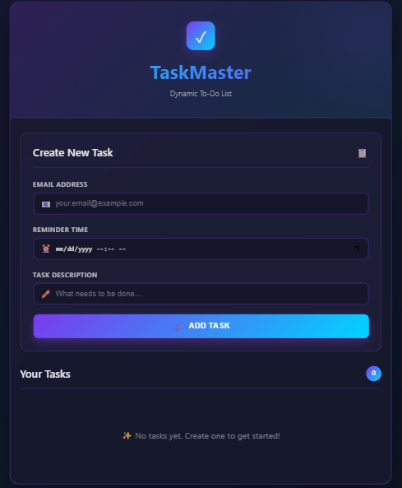

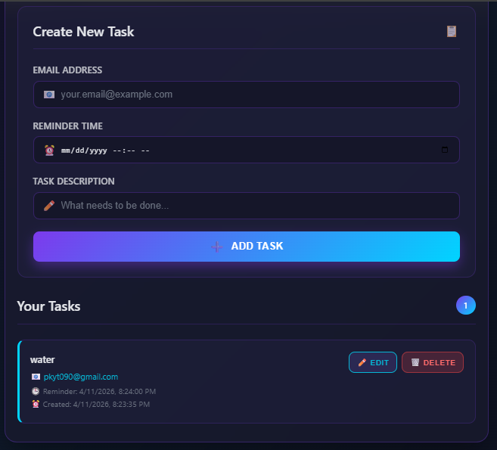

Experiment 5: Simple Blog Platform (Flask CRUD)

Aim
To design and develop a simple blog application using Python Flask that demonstrates full CRUD (Create, Read, Update, Delete) operations on blog posts. The application uses in-memory storage, Jinja2 HTML templates, and a clean CSS-styled interface — running entirely on a local Flask web server without any external database.

Tech Stack
- Python 3 – Programming language
- Flask – Lightweight Python web framework
- Jinja2 – HTML templating engine (bundled with Flask)
- HTML5 & CSS3 – Frontend structure and styling
- Browser (Chrome/Edge/Firefox) – Client-side rendering

Tasks

Task 1: Project Setup & Environment
- Created project folder simple_blog
- Installed Flask via pip install flask
- Set up app.py, templates/ (base.html, index.html, create.html, edit.html), and static/ directories

Task 2: Flask App Initialization
- Imported Flask and required modules
- Initialized the Flask app and defined a home route /
- Used a Python list to store blog posts in-memory

Task 3: Create Blog Posts (Create)
- Built /create route with GET (show form) and POST (handle submission)
- Validates that title and content are non-empty before appending to the list

Task 4: View & Display Blog Posts (Read)
- Home route renders all posts using index.html and Jinja2 templating
- Each post card shows title, content, Edit and Delete buttons

Task 5: Update Blog Posts (Update)
- Built /edit/<post_id> route that pre-fills form with existing data
- Saves updated title and content on POST

Task 6: Delete Blog Posts (Delete)
- Built /delete/<post_id> route that removes post from list
- Redirects to home after deletion

Task 7 (Bonus): Styling & Navigation
- Added consistent CSS in base.html (card layout, nav bar, buttons)
- Added navigation links: Home and New Post

Source Code
app.py
# Project Title : Simple Blog Platform
# Name : Prem Kumar
# Roll Number : 2401010243
# Section : B
# Date : 2025

from flask import Flask, render_template, request, redirect, url_for

app = Flask(__name__)

# In-memory storage for blog posts
posts = []
post_id_counter = 1

@app.route('/')
def index():
return render_template('index.html', posts=posts)

@app.route('/create', methods=['GET', 'POST'])
def create():
global post_id_counter
if request.method == 'POST':
title = request.form.get('title', '').strip()
content = request.form.get('content', '').strip()
if title and content:
posts.append({'id': post_id_counter, 'title': title, 'content': content})
post_id_counter += 1
return redirect(url_for('index'))
return render_template('create.html')

@app.route('/edit/<int:post_id>', methods=['GET', 'POST'])
def edit(post_id):
post = next((p for p in posts if p['id'] == post_id), None)
if not post:
return redirect(url_for('index'))
if request.method == 'POST':
title = request.form.get('title', '').strip()
content = request.form.get('content', '').strip()
if title and content:
post['title'] = title
post['content'] = content
return redirect(url_for('index'))
return render_template('edit.html', post=post)

@app.route('/delete/<int:post_id>')
def delete(post_id):
global posts
posts = [p for p in posts if p['id'] != post_id]
return redirect(url_for('index'))

if __name__ == '__main__':
app.run(debug=True)

templates/base.html
<!DOCTYPE html>
<html lang='en'>
<head>
<meta charset='UTF-8'>
<title>Simple Blog</title>
<style>
body { font-family: Arial, sans-serif; max-width: 800px;
margin: 0 auto; padding: 20px; background: #f5f5f5; }
nav { background: #2c3e50; padding: 10px 20px; border-radius: 6px; margin-bottom: 20px; }
nav a { color: white; text-decoration: none; margin-right: 20px; font-weight: bold; }
nav a:hover { color: #3498db; }
.card { background: white; border-radius: 8px; padding: 20px;
margin-bottom: 20px; box-shadow: 0 2px 6px rgba(0,0,0,.1); }
h1 { color: #2c3e50; }
.btn { display: inline-block; padding: 8px 16px; border-radius: 4px;
text-decoration: none; font-size: 14px; cursor: pointer; border: none; }
.btn-primary { background: #3498db; color: white; }
.btn-warning { background: #e67e22; color: white; }
.btn-danger { background: #e74c3c; color: white; }
.btn:hover { opacity: .85; }
input, textarea { width: 100%; padding: 10px; margin: 8px 0 16px;
border: 1px solid #ddd; border-radius: 4px; box-sizing: border-box; }
textarea { height: 160px; resize: vertical; }
</style>
</head>
<body>
<nav>
<a href='/'>Home</a>
<a href='/create'>New Post</a>
</nav>
{% block content %}{% endblock %}
</body>
</html>

templates/index.html
{% extends 'base.html' %}
{% block content %}
<h1>Blog Posts</h1>
{% if posts %}
{% for post in posts %}
<div class='card'>
<h2>{{ post.title }}</h2>
<p>{{ post.content }}</p>
<a href='/edit/{{ post.id }}' class='btn btn-warning'>Edit</a>
<a href='/delete/{{ post.id }}' class='btn btn-danger'
onclick="return confirm('Delete this post?')">Delete</a>
</div>
{% endfor %}
{% else %}
<div class='card'><p>No posts yet. <a href='/create'>Create one!</a></p></div>
{% endif %}
{% endblock %}

templates/create.html
{% extends 'base.html' %}
{% block content %}
<div class='card'>
<h1>New Post</h1>
<form method='POST'>
<label>Title</label>
<input type='text' name='title' required>
<label>Content</label>
<textarea name='content' required></textarea>
<button type='submit' class='btn btn-primary'>Publish</button>
<a href='/' class='btn btn-warning'>Cancel</a>
</form>
</div>
{% endblock %}

templates/edit.html
{% extends 'base.html' %}
{% block content %}
<div class='card'>
<h1>Edit Post</h1>
<form method='POST'>
<label>Title</label>
<input type='text' name='title' value='{{ post.title }}' required>
<label>Content</label>
<textarea name='content' required>{{ post.content }}</textarea>
<button type='submit' class='btn btn-primary'>Save</button>
<a href='/' class='btn btn-warning'>Cancel</a>
</form>
</div>
{% endblock %}

Output Screenshots

Experiment 6: Contact Management System (Flask CRUD)

Aim
To build a Contact Management System web application using Python Flask that implements full CRUD operations — allowing users to add, view, search, edit, and delete contacts. The application stores contact data (name, phone, email) in an in-memory Python list, renders HTML pages via Jinja2 templates, and includes a live search feature.

Tech Stack
- Python 3 – Backend programming language
- Flask – Web framework for routing and request handling
- Jinja2 – Server-side HTML templating
- HTML5 & CSS3 – Frontend structure and responsive styling
- Browser – Client-side rendering and form submission

Tasks

Task 1: Project Setup & Environment
- Created project folder contact_management_system
- Installed Flask, created app.py and templates/

Task 2: Flask App Initialization
- Initialized Flask app with a home route /
- Used a Python list to store contact dictionaries in memory

Task 3: Add New Contacts (Create)
- Built /add route with a form accepting Name, Phone, Email
- Validates all fields before saving; renders add_contact.html

Task 4: View & Display Contacts (Read)
- Home page renders contacts in an HTML table
- Shows Name, Phone, Email, and action buttons for each row

Task 5: Update Contacts (Update)
- Built /edit/<cid> route that pre-fills form with current values
- Updates contact dictionary on POST submission

Task 6: Delete Contacts (Delete)
- Built /delete/<cid> route that removes contact from list
- Redirects to home page after deletion

Task 7 (Bonus): Search & Styling
- Added search bar on home page filtering by name or phone
- Applied professional table-based CSS with hover effects

Source Code
app.py
# Project Title : Contact Management System
# Name : Prem Kumar
# Roll Number : 2401010243
# Section : B
# Date : 2025

from flask import Flask, render_template, request, redirect, url_for

app = Flask(__name__)

contacts = []
contact_id_counter = 1

@app.route('/')
def index():
query = request.args.get('q', '').strip().lower()
filtered = [c for c in contacts if
query in c['name'].lower() or query in c['phone']]
return render_template('index.html', contacts=filtered, query=query)

@app.route('/add', methods=['GET', 'POST'])
def add_contact():
global contact_id_counter
if request.method == 'POST':
name = request.form.get('name', '').strip()
phone = request.form.get('phone', '').strip()
email = request.form.get('email', '').strip()
if name and phone and email:
contacts.append({'id': contact_id_counter,
'name': name, 'phone': phone, 'email': email})
contact_id_counter += 1
return redirect(url_for('index'))
return render_template('add_contact.html')

@app.route('/edit/<int:cid>', methods=['GET', 'POST'])
def edit_contact(cid):
contact = next((c for c in contacts if c['id'] == cid), None)
if not contact:
return redirect(url_for('index'))
if request.method == 'POST':
name = request.form.get('name', '').strip()
phone = request.form.get('phone', '').strip()
email = request.form.get('email', '').strip()
if name and phone and email:
contact['name'] = name
contact['phone'] = phone
contact['email'] = email
return redirect(url_for('index'))
return render_template('edit_contact.html', contact=contact)

@app.route('/delete/<int:cid>')
def delete_contact(cid):
global contacts
contacts = [c for c in contacts if c['id'] != cid]
return redirect(url_for('index'))

if __name__ == '__main__':
app.run(debug=True)

templates/base.html
<!DOCTYPE html>
<html lang='en'>
<head>
<meta charset='UTF-8'>
<title>Contact Manager</title>
<style>
body { font-family: Arial, sans-serif; max-width: 900px;
margin: 0 auto; padding: 20px; background: #f0f4f8; }
nav { background: #1a3c5e; padding: 12px 20px;
border-radius: 6px; margin-bottom: 24px; }
nav a { color: white; text-decoration: none; margin-right: 20px; font-weight: bold; }
.card { background: white; border-radius: 8px; padding: 24px;
box-shadow: 0 2px 8px rgba(0,0,0,.08); }
table { width: 100%; border-collapse: collapse; }
th { background: #1a3c5e; color: white; padding: 10px 14px; text-align: left; }
td { padding: 10px 14px; border-bottom: 1px solid #eee; }
tr:hover td { background: #f7f9fc; }
.btn { display: inline-block; padding: 6px 14px; border-radius: 4px;
text-decoration: none; font-size: 13px; cursor: pointer; border: none; }
.btn-green { background: #27ae60; color: white; }
.btn-orange { background: #e67e22; color: white; }
.btn-red { background: #e74c3c; color: white; }
input { width: 100%; padding: 10px; margin: 6px 0 14px;
border: 1px solid #ccc; border-radius: 4px; box-sizing: border-box; }
.search-bar { display: flex; gap: 10px; margin-bottom: 16px; }
.search-bar input { margin: 0; flex: 1; }
</style>
</head>
<body>
<nav>
<a href='/'>Contacts</a>
<a href='/add'>Add Contact</a>
</nav>
{% block content %}{% endblock %}
</body>
</html>

templates/index.html
{% extends 'base.html' %}
{% block content %}
<div class='card'>
<h1>Contact List</h1>
<form class='search-bar' method='GET'>
<input name='q' value='{{ query }}' placeholder='Search by name or phone...'>
<button type='submit' class='btn btn-green'>Search</button>
</form>
{% if contacts %}
<table>
<tr><th>Name</th><th>Phone</th><th>Email</th><th>Actions</th></tr>
{% for c in contacts %}
<tr>
<td>{{ c.name }}</td>
<td>{{ c.phone }}</td>
<td>{{ c.email }}</td>
<td>
<a href='/edit/{{ c.id }}' class='btn btn-orange'>Edit</a>
<a href='/delete/{{ c.id }}' class='btn btn-red'
onclick="return confirm('Delete contact?')">Delete</a>
</td>
</tr>
{% endfor %}
</table>
{% else %}
<p>No contacts found.</p>
{% endif %}
</div>
{% endblock %}

templates/add_contact.html
{% extends 'base.html' %}
{% block content %}
<div class='card'>
<h1>Add Contact</h1>
<form method='POST'>
<label>Name</label>
<input type='text' name='name' required>
<label>Phone</label>
<input type='tel' name='phone' required>
<label>Email</label>
<input type='email' name='email' required>
<button type='submit' class='btn btn-green'>Save</button>
<a href='/' class='btn btn-orange'>Cancel</a>
</form>
</div>
{% endblock %}

templates/edit_contact.html
{% extends 'base.html' %}
{% block content %}
<div class='card'>
<h1>Edit Contact</h1>
<form method='POST'>
<label>Name</label>
<input type='text' name='name' value='{{ contact.name }}' required>
<label>Phone</label>
<input type='tel' name='phone' value='{{ contact.phone }}' required>
<label>Email</label>
<input type='email' name='email' value='{{ contact.email }}' required>
<button type='submit' class='btn btn-green'>Update</button>
<a href='/' class='btn btn-orange'>Cancel</a>
</form>
</div>
{% endblock %}

Output Screenshots

Experiment 7: E-Commerce Website (HTML, CSS & JavaScript)

Aim
To design and build a fully functional client-side e-commerce website using HTML5, CSS3, and vanilla JavaScript. The application includes a product listing grid, a dynamic shopping cart with quantity controls, real-time price calculation, a simulated checkout flow, and order confirmation — all without any backend server.

Tech Stack
- HTML5 – Page structure and semantic markup
- CSS3 – Grid layout, Flexbox, transitions, sticky header, modal overlays
- JavaScript (ES6+) – DOM manipulation, cart logic, localStorage persistence
- Browser LocalStorage – Persist cart data across page reloads
- No external frameworks – Pure vanilla implementation

Tasks

Task 1: Project Setup & Structure
- Created ecommerce_website/ with index.html, style.css, script.js
- Added header comments with project details

Task 2: Product Listing Page
- Defined 6 products in a JS array with name, price, description, icon
- Dynamically rendered product cards in a CSS Grid layout using renderProducts()

Task 3: Styling & Layout (CSS)
- Applied gradient header, card hover effects, responsive grid, modal overlays
- Consistent typography, color palette, and spacing across all sections

Task 4: Shopping Cart Functionality
- addToCart() adds or increments cart items
- renderCart() dynamically updates cart sidebar with item list and totals
- updateQty() handles + / − quantity controls; removeItem() removes entries

Task 5: Cart Summary & Price Calculation
- Individual item total = price × qty
- Overall total computed with Array.reduce() and updated live on every change

Task 6: Checkout Simulation
- Checkout modal collects Name and Address
- placeOrder() validates inputs, shows personalized confirmation message, and clears cart

Task 7 (Bonus): Enhanced Features
- + / − quantity buttons in cart sidebar
- Cart persisted in localStorage — survives page reload
- Hover transitions on product cards and buttons

Source Code
index.html
<!DOCTYPE html>
<!-- Project: E-Commerce Website | Name: Prem Kumar | Roll: 2401010243 -->
<html lang='en'>
<head>
<meta charset='UTF-8'>
<title>ShopEasy</title>
<link rel='stylesheet' href='style.css'>
</head>
<body>
<header>
<div class='header-inner'>
<h1 class='logo'>ShopEasy</h1>
<button class='cart-btn' onclick='toggleCart()'>
🛒 Cart <span id='cart-count'>0</span>
</button>
</div>
</header>

<main>
<section id='products'>
<h2>Our Products</h2>
<div class='grid' id='product-grid'></div>
</section>

<!-- Cart Sidebar -->
<aside id='cart-sidebar' class='hidden'>
<h2>Shopping Cart</h2>
<div id='cart-items'></div>
<div class='cart-total'>Total: <strong id='cart-total'>₹0</strong></div>
<button class='btn btn-checkout' onclick='checkout()'>Proceed to Checkout</button>
<button class='btn btn-close' onclick='toggleCart()'>Close</button>
</aside>

<!-- Checkout Modal -->
<div id='checkout-modal' class='modal hidden'>
<div class='modal-box'>
<h2>Checkout</h2>
<label>Full Name</label>
<input type='text' id='c-name' placeholder='Your name'>
<label>Delivery Address</label>
<input type='text' id='c-addr' placeholder='123 Main St, City'>
<button class='btn btn-checkout' onclick='placeOrder()'>Place Order</button>
<button class='btn btn-close' onclick='closeModal()'>Cancel</button>
</div>
</div>

<!-- Confirmation -->
<div id='confirm-modal' class='modal hidden'>
<div class='modal-box success'>
<h2>✅ Order Placed!</h2>
<p id='confirm-msg'></p>
<button class='btn btn-checkout' onclick='closeConfirm()'>Continue Shopping</button>
</div>
</div>
</main>

<script src='script.js'></script>
</body>
</html>

style.css
/* style.css – ShopEasy E-Commerce */
* { box-sizing: border-box; margin: 0; padding: 0; }
body { font-family: 'Segoe UI', Arial, sans-serif; background: #f5f7fa; color: #333; }

header { background: linear-gradient(135deg,#1a3c5e,#2e74b5);
padding: 16px 32px; position: sticky; top:0; z-index:100;
box-shadow: 0 2px 8px rgba(0,0,0,.2); }
.header-inner { display:flex; align-items:center; justify-content:space-between; max-width:1200px; margin:0 auto; }
.logo { color:white; font-size:1.8rem; letter-spacing:1px; }

main { max-width:1200px; margin:32px auto; padding:0 20px; }
h2 { font-size:1.5rem; margin-bottom:20px; color:#1a3c5e; }

/* Product Grid */
.grid { display:grid; grid-template-columns:repeat(auto-fill,minmax(240px,1fr)); gap:24px; }
.product-card { background:white; border-radius:12px; padding:20px;
box-shadow:0 2px 10px rgba(0,0,0,.08); transition:transform .2s,box-shadow .2s; }
.product-card:hover { transform:translateY(-4px); box-shadow:0 8px 24px rgba(0,0,0,.12); }
.product-img { font-size:3.5rem; text-align:center; margin-bottom:12px; }
.product-name { font-weight:700; font-size:1.1rem; margin-bottom:6px; }
.product-desc { color:#666; font-size:.9rem; margin-bottom:12px; min-height:40px; }
.product-price { font-size:1.3rem; font-weight:700; color:#e67e22; margin-bottom:16px; }

/* Buttons */
.btn { display:inline-block; padding:10px 20px; border:none; border-radius:6px;
cursor:pointer; font-size:.95rem; transition:opacity .2s,transform .1s; }
.btn:hover { opacity:.88; transform:scale(1.02); }
.btn-add { background:#27ae60; color:white; width:100%; text-align:center; }
.cart-btn { background:rgba(255,255,255,.2); color:white; border:1px solid rgba(255,255,255,.4);
padding:8px 18px; border-radius:20px; cursor:pointer; font-size:1rem;
transition:background .2s; }
.cart-btn:hover { background:rgba(255,255,255,.35); }
.btn-checkout { background:#2e74b5; color:white; margin-top:12px; width:100%; }
.btn-close { background:#e74c3c; color:white; margin-top:8px; width:100%; }

/* Cart Sidebar */
#cart-sidebar { position:fixed; right:0; top:0; height:100vh; width:340px;
background:white; box-shadow:-4px 0 20px rgba(0,0,0,.15);
padding:24px; overflow-y:auto; z-index:200; }
.hidden { display:none !important; }
.cart-item { display:flex; justify-content:space-between; align-items:center;
padding:10px 0; border-bottom:1px solid #eee; }
.cart-item-info { flex:1; }
.cart-item-name { font-weight:600; }
.cart-item-price { color:#e67e22; font-size:.9rem; }
.qty-controls { display:flex; align-items:center; gap:8px; }
.qty-btn { background:#eee; border:none; width:26px; height:26px; border-radius:4px;
cursor:pointer; font-size:1rem; font-weight:700; }
.qty-btn:hover { background:#ddd; }
.qty-val { min-width:20px; text-align:center; font-weight:600; }
.remove-btn { background:#fdecea; color:#e74c3c; border:none; padding:4px 8px;
border-radius:4px; cursor:pointer; font-size:.85rem; margin-left:8px; }
.cart-total { font-size:1.2rem; padding:14px 0; border-top:2px solid #eee; margin-top:8px; }

/* Modals */
.modal { position:fixed; inset:0; background:rgba(0,0,0,.5);
display:flex; align-items:center; justify-content:center; z-index:300; }
.modal-box { background:white; border-radius:12px; padding:32px;
width:90%; max-width:440px; box-shadow:0 10px 40px rgba(0,0,0,.2); }
.modal-box input { width:100%; padding:10px; border:1px solid #ccc;
border-radius:6px; margin:6px 0 16px; font-size:1rem; }
.success { text-align:center; }
.success p { color:#555; margin-top:10px; }

script.js
// script.js – ShopEasy E-Commerce
// Products data
const PRODUCTS = [
{ id:1, name:'Wireless Headphones', price:2999, desc:'Noise-cancelling, 30hr battery', icon:'🎧' },
{ id:2, name:'Mechanical Keyboard', price:3499, desc:'RGB backlit, tactile switches', icon:'⌨️' },
{ id:3, name:'Desk Lamp', price:899, desc:'LED, adjustable brightness', icon:'💡' },
{ id:4, name:'Webcam HD 1080p', price:1999, desc:'Auto-focus, built-in mic', icon:'📷' },
{ id:5, name:'USB-C Hub 7-in-1', price:1299, desc:'HDMI, SD card, 3x USB ports', icon:'🔌' },
{ id:6, name:'Laptop Stand', price:799, desc:'Aluminium, foldable, portable', icon:'💻' },
];

let cart = JSON.parse(localStorage.getItem('cart') || '[]');

// Render products
function renderProducts() {
const grid = document.getElementById('product-grid');
grid.innerHTML = PRODUCTS.map(p => `
<div class='product-card'>
<div class='product-img'>${p.icon}</div>
<div class='product-name'>${p.name}</div>
<div class='product-desc'>${p.desc}</div>
<div class='product-price'>₹${p.price.toLocaleString()}</div>
<button class='btn btn-add' onclick='addToCart(${p.id})'>Add to Cart</button>
</div>`).join('');
}

// Add to cart
function addToCart(id) {
const existing = cart.find(i => i.id === id);
if (existing) { existing.qty++; }
else { const p = PRODUCTS.find(p => p.id === id);
cart.push({ ...p, qty: 1 }); }
saveCart();
updateCartCount();
renderCart();
}

// Update qty
function updateQty(id, delta) {
const item = cart.find(i => i.id === id);
if (!item) return;
item.qty += delta;
if (item.qty <= 0) cart = cart.filter(i => i.id !== id);
saveCart();
updateCartCount();
renderCart();
}

// Remove item
function removeItem(id) {
cart = cart.filter(i => i.id !== id);
saveCart();
updateCartCount();
renderCart();
}

// Render cart
function renderCart() {
const el = document.getElementById('cart-items');
const total = cart.reduce((s, i) => s + i.price * i.qty, 0);
el.innerHTML = cart.length ? cart.map(i => `
<div class='cart-item'>
<div class='cart-item-info'>
<div class='cart-item-name'>${i.icon} ${i.name}</div>
<div class='cart-item-price'>₹${(i.price * i.qty).toLocaleString()}</div>
</div>
<div class='qty-controls'>
<button class='qty-btn' onclick='updateQty(${i.id},-1)'>−</button>
<span class='qty-val'>${i.qty}</span>
<button class='qty-btn' onclick='updateQty(${i.id},1)'>+</button>
<button class='remove-btn' onclick='removeItem(${i.id})'>✕</button>
</div>
</div>`).join('') : '<p style="color:#999">Your cart is empty.</p>';
document.getElementById('cart-total').textContent = '₹' + total.toLocaleString();
}

function updateCartCount() {
document.getElementById('cart-count').textContent = cart.reduce((s,i)=>s+i.qty,0);
}

function toggleCart() {
document.getElementById('cart-sidebar').classList.toggle('hidden');
renderCart();
}

function saveCart() { localStorage.setItem('cart', JSON.stringify(cart)); }

function checkout() {
if (!cart.length) { alert('Your cart is empty!'); return; }
document.getElementById('checkout-modal').classList.remove('hidden');
}

function placeOrder() {
const name = document.getElementById('c-name').value.trim();
const addr = document.getElementById('c-addr').value.trim();
if (!name || !addr) { alert('Please fill in all fields.'); return; }
const total = cart.reduce((s, i) => s + i.price * i.qty, 0);
document.getElementById('confirm-msg').textContent =
`Thank you, ${name}! Your order of ₹${total.toLocaleString()} will be delivered to: ${addr}`;
cart = [];
saveCart();
updateCartCount();
document.getElementById('checkout-modal').classList.add('hidden');
document.getElementById('cart-sidebar').classList.add('hidden');
document.getElementById('confirm-modal').classList.remove('hidden');
}

function closeModal() { document.getElementById('checkout-modal').classList.add('hidden'); }
function closeConfirm() { document.getElementById('confirm-modal').classList.add('hidden'); }

// Init
renderProducts();
updateCartCount();

Output Screenshots

